User Guidelines
By Gang-Qing Hu
7/31/2026
General 2
Install 2
Inputs 3
Settings 4
Outputs 5
Contacts 5

General
TriTISA is a Bayesian methodology based method for translation initiation site (TIS) prediction in microbial genomes. It runs in a non-supervised iterative manner and supports for post-processing gene annotations from public databases such as GenBank and RefSeq and widely used gene finders such as Glimmer and GeneMark.
The code is written in standard C++ and can be run on any system with a C++ compiler. We open the codes under the GNU GPL license to allow any part to be modified by users for specific research purpose.

Install
TriTISA has been tested on windows and LINUX/UNIX platforms. For window system, in addition to source codes, we provide an executable file named “TriTISA.exe”. For LINUX/UNIX system, users need to compile the codes with a C++ compiler such as GCC (http://gcc.gnu.org). We have created a script file named “install” for being compiled with G++ (Fig. 1). The file may be edited to suit other compilers. For example, for an Intel C++ compiler (ICPC, http://www.intel.com), just replace all the “G++” with “icpc”. You may also need to apply the “dos2unix” command to format the “install” and “settings” files before compiling and program running, respectively.
Please make the file “install” be executable by typing “chmod +x install” and then active it by “./install” to install. An executable file called “TriTISA” is then created.

Figure 1 the install scripts

G++ GenomeSeq.cpp -c
G++ GenomeInfo.cpp -c
G++ Matrix.cpp -c
G++ OftenUsedOperatLib.cpp -c
G++ SequenceTransform.cpp -c
G++ TriTISA.cpp -c
G++ GenomeSeq.o GenomeInfo.o Matrix.o OftenUsedOperatLib.o SequenceTransform.o TriTISA.o -O2 -o TriTISA
chmod +x TriTISA
For an Intel C++ compiler, just replace all “G++” with “icpc”.

Inputs
TriTISA is a command line program that operates from the command line namely “cmd.exe” for windows system or from a shell for LINUX/UNIX system. Two inputs are required: the FASTA format of the whole genome sequence (file1) and initial gene annotations (file2). To run the program, just type “TriTISA.exe file1 file2” for windows and “./TriTISA file1 file2” for LINUX/UNIX.
The FASTA files refer to those in GenBank/RefSeq with “fna” as file extension name. The current version accepts four kinds of annotation inputs (Fig. 2):
- GenBank/RefSeq (default): gene annotations from GenBank/RefSeq with “ptt” as file extension name.
- Glimmer 3: gene predictions from Glimmer 3, which may be downloaded from GenBank/RefSeq with “Glimmer3” as file extension name.
- GeneMark: gene predictions from GeneMark, which may be downloaded from GenBank/RefSeq with “GeneMarkHMM-2.6m” as file extension name.
- MED: gene prediction from MED 2.0 (http://ctb.pku.edu.cn/main/SheGroup/MED2.htm).

Figure 2 screen shots of different inputs, shown for E. coli K12
a) GenBank/RefSeq b) Glimmer 3
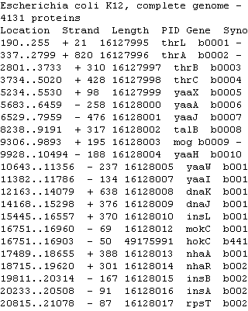
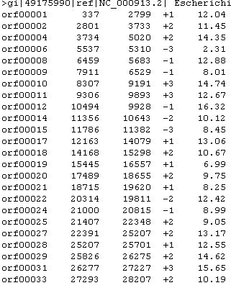

c) GeneMark d) MED 2.0
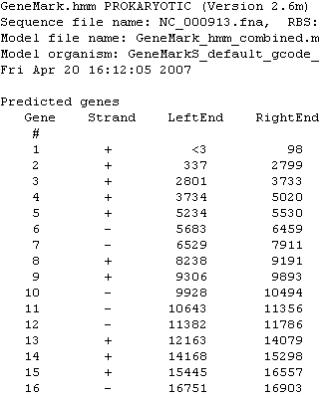
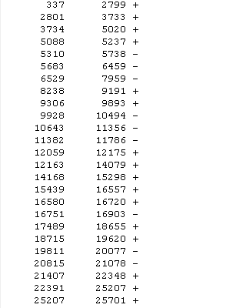

Settings
By default, TriTISA processes annotations from GenBank/RefSeq and for genomes using triples ATG/CTG/GTG/TTG as start codon and triplets TAA/TAG/TGA as stop codon. User should edit the file named “settings” to cope with other situations, for example for Mycoplasma one need to comment off the TGA as a stop codon by “#”.
The “settings” file has three sections with self-explanation keywords (Fig. 3):
- The window length of the first order Makov models for the sequence around TIS.
- Types of start codon and stop codon used.
- Specified annotation format.
Figure 3 the install scripts
# CAUTION: CASE AND SAPCE SENSITIVE.
# CAUTION: MAKE SURE THE FILE IS IN LINIX/UNIX FORMAT
# TIPS: USING DOS2UNIX TO CONVERT A WINDOW FILE TO A LINIX/UNIX FILE.
# COMMENTS ARE BEGINNING WITH "#", AND WILL BE IGNORED BY THE PROGRAM
# CASCADE COMBINATION OF MARKOV MODEL FROM LOWER ORDER TO HIGHER ORDER
# THREE MODEL ARE CASCADED (BY DEFAULT), NAMELY 0-TH, 1-TH, 2-ND ORDERS
# MORE MODEL CAN BE ADDED BY ADJUSTING THE MAXORDER OPTION
MAXORDER=2
# PARAMTERS FOR i-TH ORDER MARKOV MODEL
UPSTREAM=50
DOWNSTREAM=15
# START CODON AND STOP CODON, ADD YOUR CODON XXX BY ADDING
# "START=XXX" OR "STOP=XXX", OR REMOVE A CODON BY COMMENTING
# OFF THE ACCORDING LINE BY "#"
START=ATG
START=CTG
START=GTG
START=TTG
STOP=TAA
STOP=TGA
STOP=TAG
# GENOME ANNOTATION FORMAT. CURRENTLY, WE SUPPORT FOUR
# KINDS OF INPUT: REFSEQ (DEFAULT), GENBANK, GLIMMER3,
# GENEMARKS, and MED. PLEASE REPALCE THE BELOW VALUE
# BY GENBANK, GLIMMER3, GENEMARKS and MED IF YOU USE
# ONE OF THE OTHER FOUR INPUTS.
INPUT=REFSEQ

Outputs
TriTISA outputs three files for each input. The first contains the predicted TIS of each gene. The second has Bayesian scores for each candidate start codon. The final describe the parameters learned. The first two files are organized in the MED 2.0 format, except for three added columns, which correspond to the Bayesian probabilities P(U|S), P(T|S), and P(D|S), respectively (see the paper for explanations on U, T and D). The relationship between formats MED 2.0 and GenBank/RefSeq is shown in figure 4.

Figure 4 Relationship between formats GenBank/RefSeq and MED 2.0
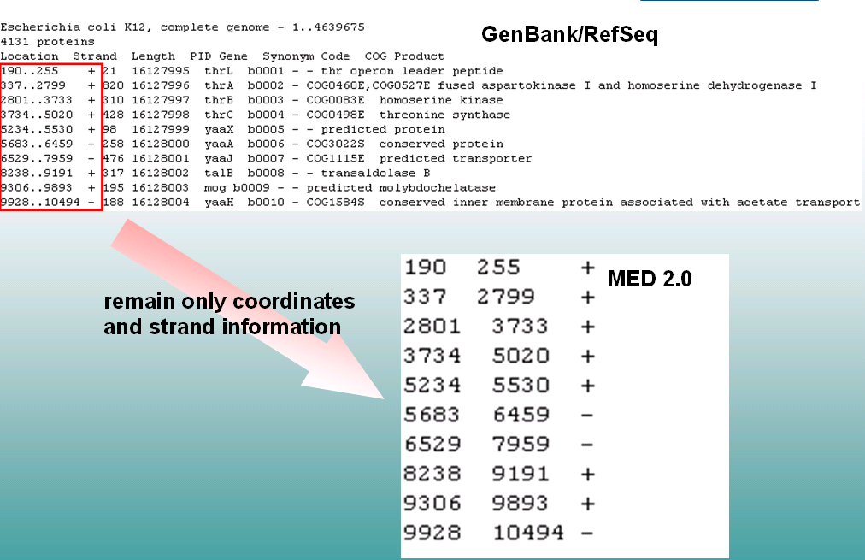

Parameters saved include 1) the maximal order Markov models for each TIS category, 2) probabilities for a total of n false TISs upstream to true TIS, 3) the maximal number of candidate considered for each gene, and 4) the prior-probabilities for the three TIS categories. Note 3) and 4) can be calculated from 2) (see the paper for details).

Contacts
hugangqing@ctb.pku.edu.cn

